WHY WE USE PLC SOFTWARE??

**🛠️** PLC Software: Your Digital Toolbox

Think of your PLC as a super‑powered robot. Without the right software, though, it’s just an expensive paperweight.  
👉 **The programming software is where the magic happens**—you write commands, debug problems, and bring that controller to life.

**Pro‑tip:** Picking your PLC software is just as important as picking the hardware.  
You don’t want to grab an amazing controller only to find out the software feels clunky, confusing, or downright frustrating. Been there… not fun.

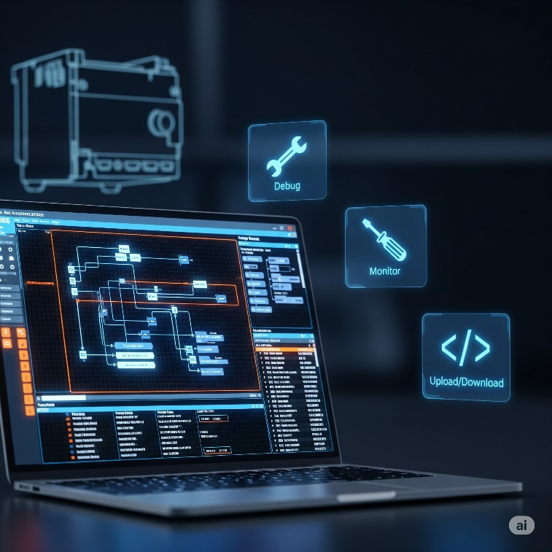

**🎮** Built‑in Simulator: Your Virtual Playground

A **built‑in simulator** is like having a digital clone of your PLC on your computer. It gives you a safe environment to test your ladder logic (or other code) *without touching the real machine.*

✅ **Why it’s a lifesaver:**

* You can test your code before going live.
* Try out different scenarios and catch logic errors early.
* Avoid real‑world mishaps or production downtime.
* Many simulators even mimic analog sensors and buttons, giving you a full‑blown dry run.

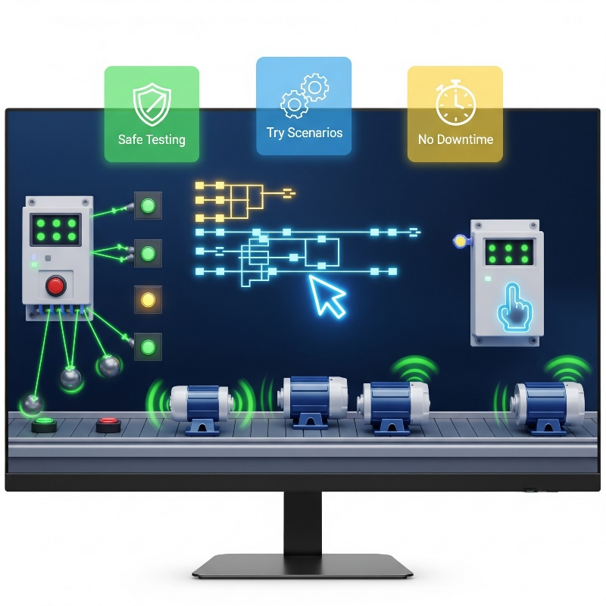

👀 Bottom line:

The right software—especially one with a good simulator—lets you build, test, and tweak your programs with confidence before a single real‑world output ever switches on.

**🔥** 2. Hot Swapping & Run‑Time Transfers: No Downtime, Baby!

Once your production line is humming, making changes can feel like defusing a bomb—one wrong move and you’re shutting everything down. But with the right software (and hardware support), you don’t have to slam the brakes on your entire system just to make small tweaks.

**🚀** Hot Swapping

This lets you replace physical parts of your PLC system—like an I/O module—*while everything is still powered on and running*.  
👉 Imagine swapping a tire on a moving car… okay, not quite that wild, but you get the picture!  
**Result:** Less downtime, less panic, and way fewer angry calls from the production manager.

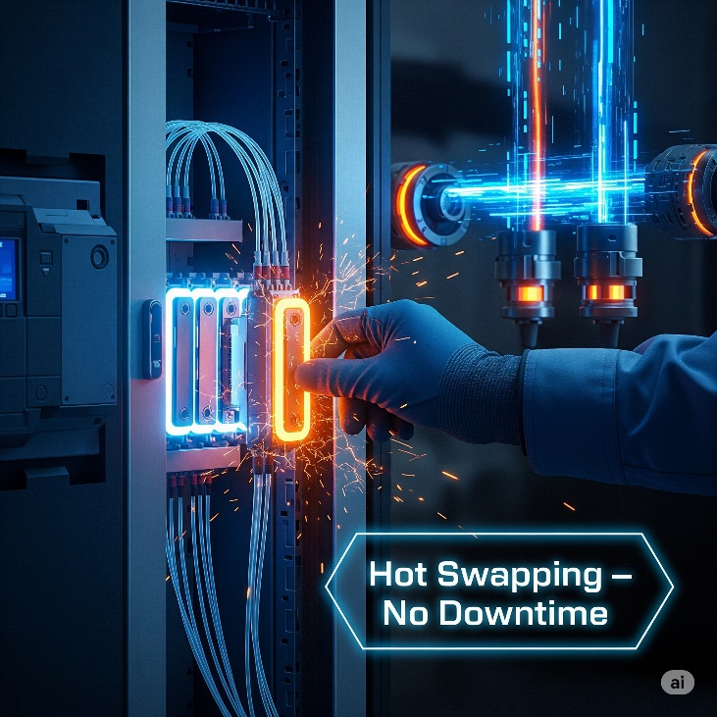

**⚡** Run‑Time Transfers (a.k.a. Online Edits)

Need to tweak your code? With run‑time transfers, you can update and download changes to your PLC program *without stopping the controller*.  
👉 Think of it like installing a new feature on your phone without rebooting the whole device.

**💎** Why it’s a big deal:

✅ No full system shutdowns just for minor edits.  
✅ Saves hours (and big money) on maintenance.  
✅ Keeps production flowing while you upgrade or debug.

**Bottom line:** Hot swapping and run‑time edits aren’t just nice‑to‑have—they’re game‑changers for any system that needs to keep running 24/7.

**✨** 3. Auto Discovery: Plug‑and‑Play Magic

This one’s a total time‑saver. With auto discovery, your PLC software can *automatically detect* the hardware you’ve connected—no tedious manual setup.

**⚡** Why it’s clutch:

Instead of manually telling the software, “Hey, I plugged in this I/O module here, that one over there…”, you just slot the modules in, power up, and **boom**—the software instantly recognizes what’s connected.

✅ It assigns addresses (or *tags*) based on where each module is plugged in.  
✅ You can keep those default settings or fine‑tune them later.  
✅ Some advanced systems even auto‑detect **other smart devices**—like motor drives or special sensors—saving you even more setup time.

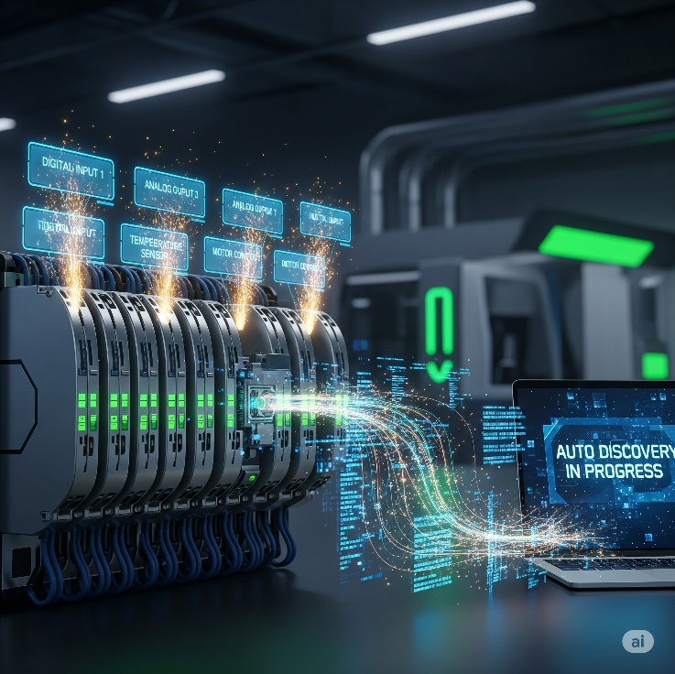

**👀** Bottom line: Auto discovery turns what used to be a painstaking checklist into a quick, seamless setup. Plug it, power it, let the software do the heavy lifting, and you’re ready to roll. 🚀

**📊** 4. Data View & Histograms: Seeing What’s Up, Live!

These features are like windows straight into your PLC’s brain. They let you watch values change in real time and even help you tweak things on the fly.

**👓** Data View Windows

* Watch live PLC values as the program runs.
* Check if a sensor is active, see a temperature reading, or watch a timer counting down.
* You can even adjust certain values on the spot for testing.

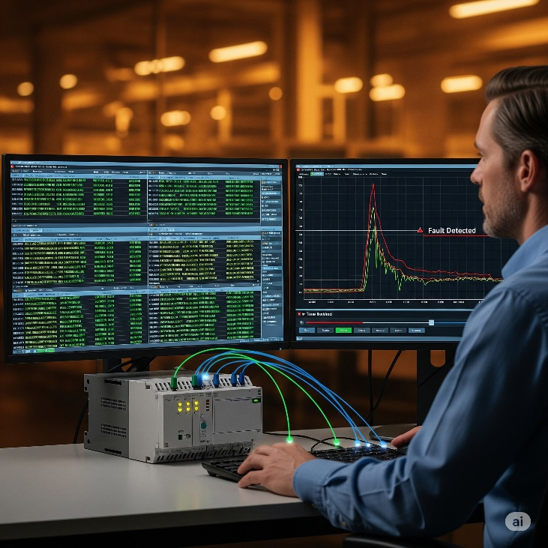

**📈** Graphical Trend Charts & Histograms

* Visualize how values change over time—like temperature trends in an oven or how often a pushbutton is hit.
* Perfect for troubleshooting: you can rewind the data to see what went wrong and when.

**Bottom line:** These tools turn raw numbers into a clear picture of what your system is doing, making debugging and fine‑tuning way easier.

**🔐** 5. Security: Who’s Got the Keys? **👤**

Controlling access to your PLC is *huge*—you don’t want just anyone poking around in your control logic.

**🚧** Why it’s clutch:

* Good PLC software lets you set up user accounts with different permission levels.
* Only authorized users can make edits, upload programs, or tweak critical settings.
* Think of it like admin vs. guest access on a computer—keeps your system safe from accidental (or intentional) chaos.

**Bottom line:** Security features protect your system, your production line, and even your people. Don’t skip it.



**🔍** 6. Search & Cross Reference: Your Code GPS

When your program gets big and messy, these tools save your brain (and your time). You’ll use them all the time.

**🔎 Search:** Find exactly where an address, variable, comment, or instruction is used in your program.

**🔄 Search & Replace:** Find something and update it everywhere it appears — quick, consistent edits.

**🗺️ Cross Reference:** Shows you *every single place* a specific tag or address appears in your logic.

**🚨 Why it’s clutch:** It’s like having GPS in a huge city of code. Instead of scrolling forever, you jump straight to what you need and make safe changes without missing anything.



**📖** 7. Help Files: Your Built‑In Guru

Great PLC software comes with solid, easy‑to‑use help files.

Why it’s clutch:  
When you hit a wall —  
✅ New instruction you’ve never used?  
✅ Code acting weird?  
✅ Not sure what that error means?

The help files should break it down with clear steps, visuals, screenshots, and examples.  
It’s like having an experienced mentor sitting beside you, ready to explain whenever you’re stuck.



**🌐** 8. Connectivity: Plugging In & Getting Online

This is all about how your PC connects to the PLC for programming, monitoring, or updates.

**💻** USB Connections:

Most modern PLCs let you plug in directly via USB. Fast and easy… but your laptop needs to be right there beside the PLC.



Industrial grade cables for direct programming of plcs from computers

**⚡ In practice – 2025:**

👉 You come in with your laptop.  
👉 Industrial USB programming cable.  
👉 Hit download, sending it the new ladder logic.  
👉 PLC accepts, updates, reboots or live‑updates.  
👉 Machine goes back to work with the new brain/Instructions.

💡 **Pro tip:** In critical environments, engineers often do this in a controlled window (like scheduled maintenance) to avoid unexpected downtimes. But technically, the workflow is exactly what we described above.

**🌍** Ethernet:

For networked systems, Ethernet is king. Connect over long distances, just like home internet.  
(*Pro‑tip:* check if you need extra drivers or software for the connection — some setups can be picky.)

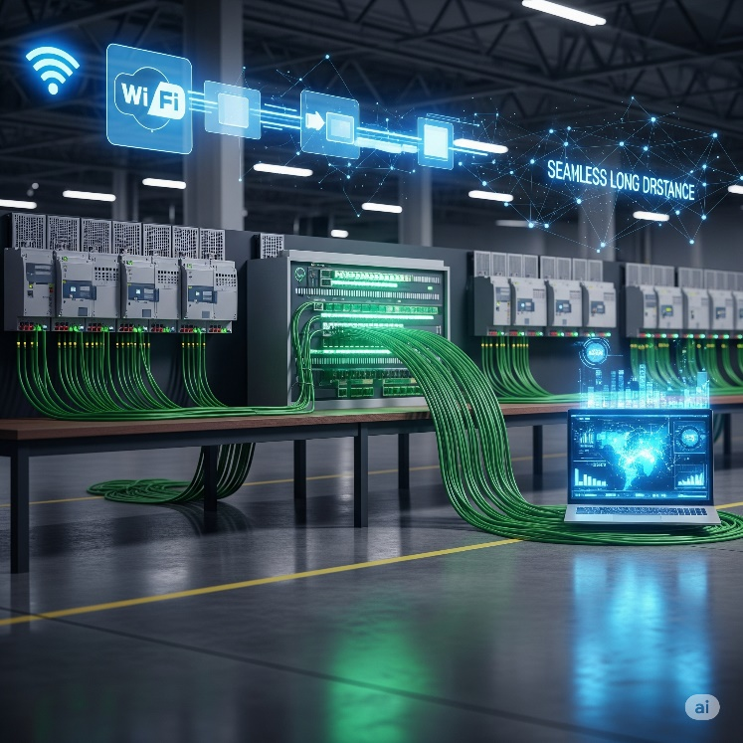

**📦** USB Project Transfers:

Some PLCs let you load a project onto a USB stick and plug it straight into the PLC. Perfect for remote sites where lugging a laptop isn’t practical.

**Why it’s clutch:** Easy, reliable connections mean less time fighting with cables and settings… and more time actually programming and testing.

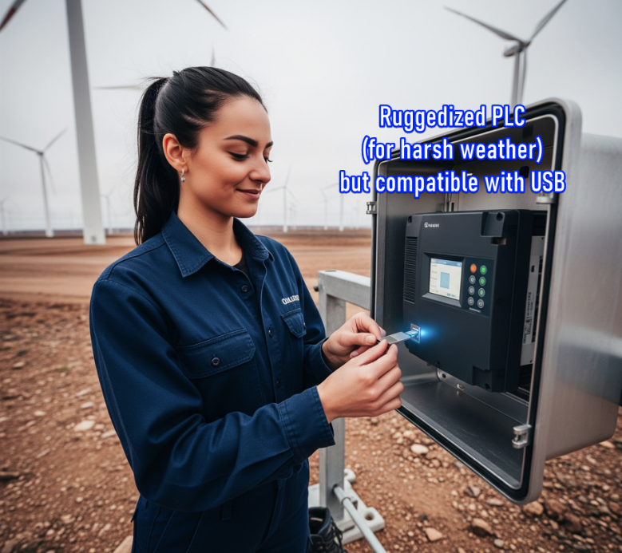

**🎨** 9. Customizable Layouts: Make It Yours! **✨**

Even the most powerful software feels like torture if it’s clunky to use.

Why it’s clutch:  
Good PLC software lets you shape your workspace:  
✅ Move and dock windows wherever you want.  
✅ Adjust text size, colors, and display options.  
✅ Tweak accessibility settings to match your workflow.

Think of it like setting up your IDE for C++ or Python—once it feels comfortable and efficient, your productivity shoots through the roof.

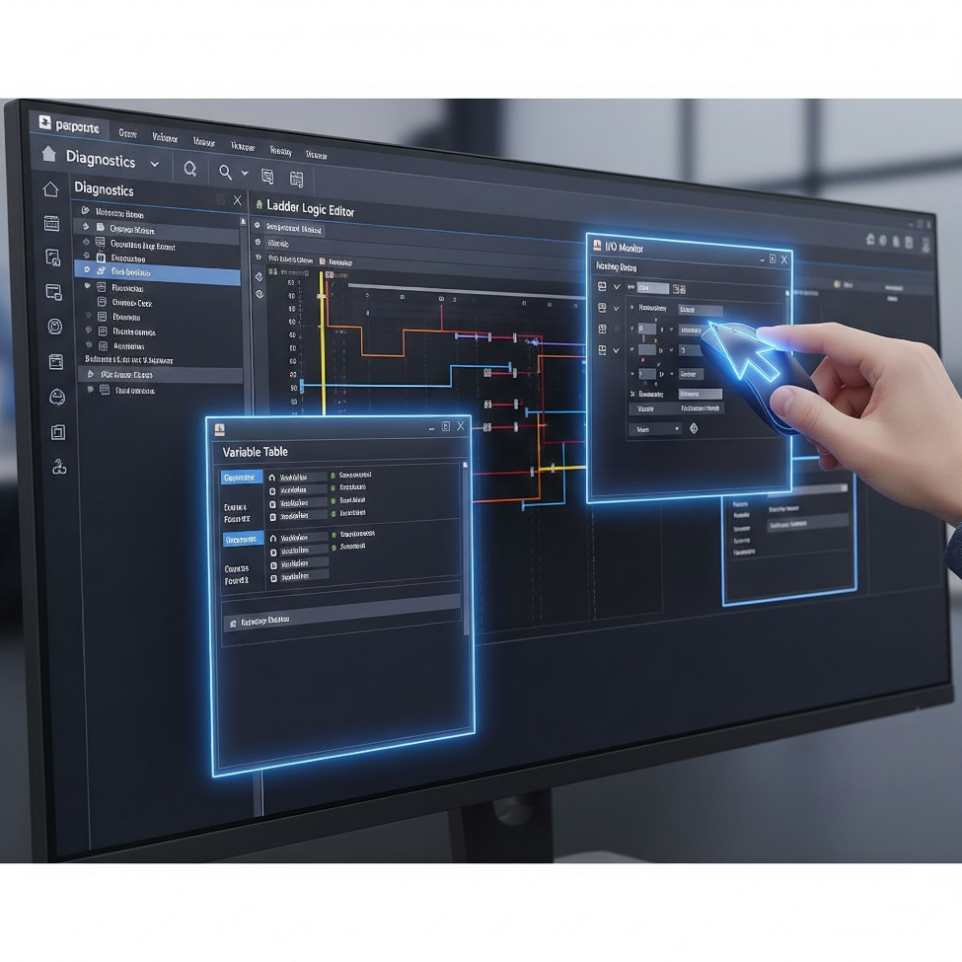

**🤔** 10. Project Compare: What Did I Change?! **📜**

Ever download a project and later wonder, *“Wait… why’s it acting weird? What did I even change?”*  
Been there, done that.

Why it’s clutch:  
Project compare tools show you:  
✅ The differences between your current project and an older saved version.  
✅ Or between your file and what’s actually loaded in the PLC.

You get a detailed breakdown of every change. Perfect for debugging, tracking revisions, and making sure you didn’t accidentally nuke something important.

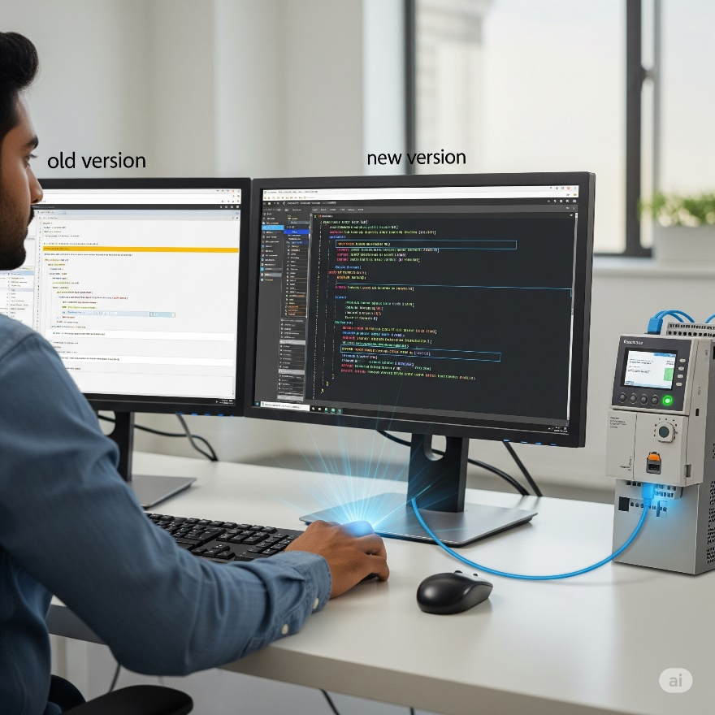

**🐛** 11. Debugging Tools: Squashing Bugs Like a Pro **💥**

Bugs happen. Good debugging tools turn frustration into control.

Why it’s clutch:  
✅ Step through your logic rung by rung (or line by line) to watch how it behaves in real time.  
✅ Pause execution at critical points to see what’s really going on.  
✅ Temporarily disable sections of code or simulate error conditions to test your logic.

**Bottom line:** Debugging tools aren’t just helpful—they’re essential for finding exactly where your logic went sideways and fixing it fast.



**📱** 12. Web Server & Mobile Apps: Control on the Go **🌐**

Modern PLCs aren’t chained to the factory floor anymore—now you can keep tabs from anywhere.

**✅** Web Server Functionality:

Your PLC can host its own little web page. Just type in the PLC’s IP address in a browser and boom—you can see live diagnostics, process values, and status updates from anywhere with internet access.

**✅** Mobile Apps:

Many brands offer mobile apps that talk directly to your PLC.

**💡** Why it’s clutch:

Imagine getting real‑time status updates while you’re grabbing lunch, or seeing an alert pop up on your phone if something goes wrong. Faster response times, less downtime, and total peace of mind wherever you are.

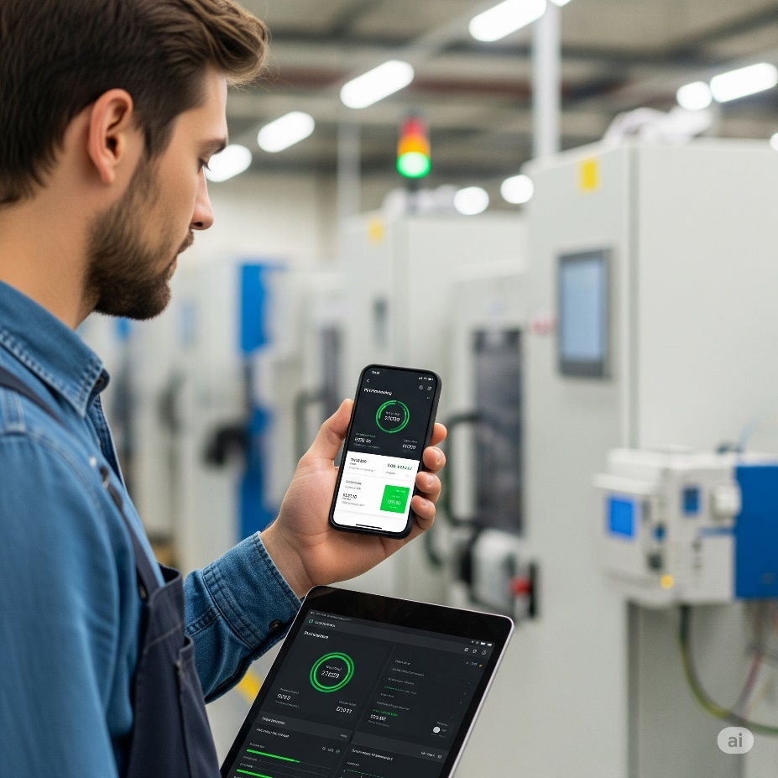

**📧** 13. Email Integration: Get Notified! **🚨**

Some PLCs can send emails all on their own.

**💡** Why it’s clutch:  
Set up email alerts for critical events—machine faults, low material warnings, safety stops, you name it.  
Your PLC instantly notifies you and your team so you can jump in before a small problem turns into a production disaster.

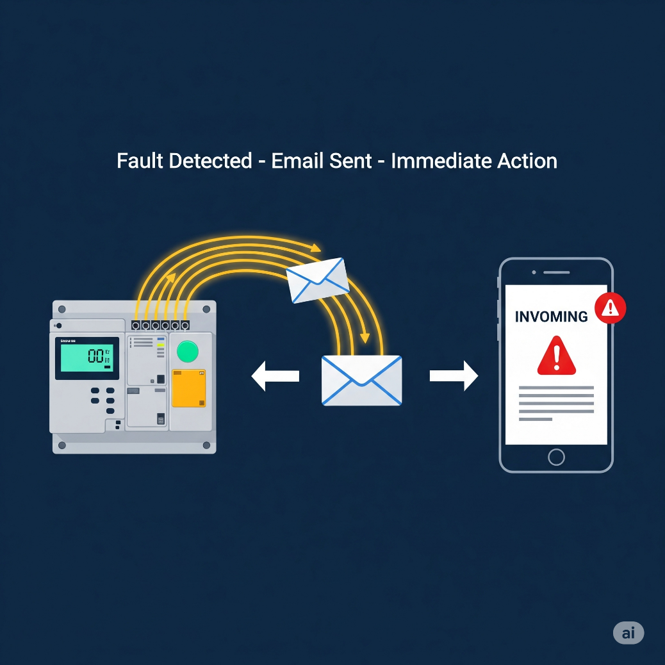

**🌀** 14. PID Options: Smooth Operator Mode **⚙️**

Process control pros, listen up—PID (Proportional, Integral, Derivative) loops are key for smooth, stable control.

**💡** Why it’s clutch:  
Pick software with:  
✅ Built‑in PID instructions.  
✅ Easy‑to‑use monitoring and tuning tools.  
✅ Bonus: *Auto‑tuning* features that calculate the best PID settings for you.  
Less headache, more precision, better performance.

In Programmable Logic Controller (PLC) programming, a PID (Proportional-Integral-Derivative) controller is a control loop feedback mechanism widely used to regulate various process variables such as temperature, pressure, or flow.

It works by continuously calculating an error value as the difference between a desired setpoint and a measured process variable, then applying a corrective action based on proportional, integral, and derivative terms. This ensures the process variable approaches and maintains the desired setpoint, even in the face of disturbances.



**🔢** 15. Powerful Math Functions: Crunch Those Numbers! **➕**

Modern processes often need heavy math—don’t settle for basic.

**💡** Why it’s clutch:  
Great PLC software lets you enter advanced equations directly (square roots, scaling formulas, custom calculations) without messy workarounds.  
✅ Cleaner code.  
✅ Less wasted time.  
✅ Ready for advanced control logic.



**📝** 16. Task Manager: Organize Your Program’s Flow **⏱️**

Instead of running one massive chunk of code over and over, a task manager lets you split your program into smaller pieces.

**💡** Why it’s clutch:  
✅ Run tasks only when needed (every scan, once per second, only on startup, or triggered by an event).  
✅ Optimizes scan time and keeps your PLC super responsive.  
✅ Makes your logic way easier to maintain—no spaghetti code here.

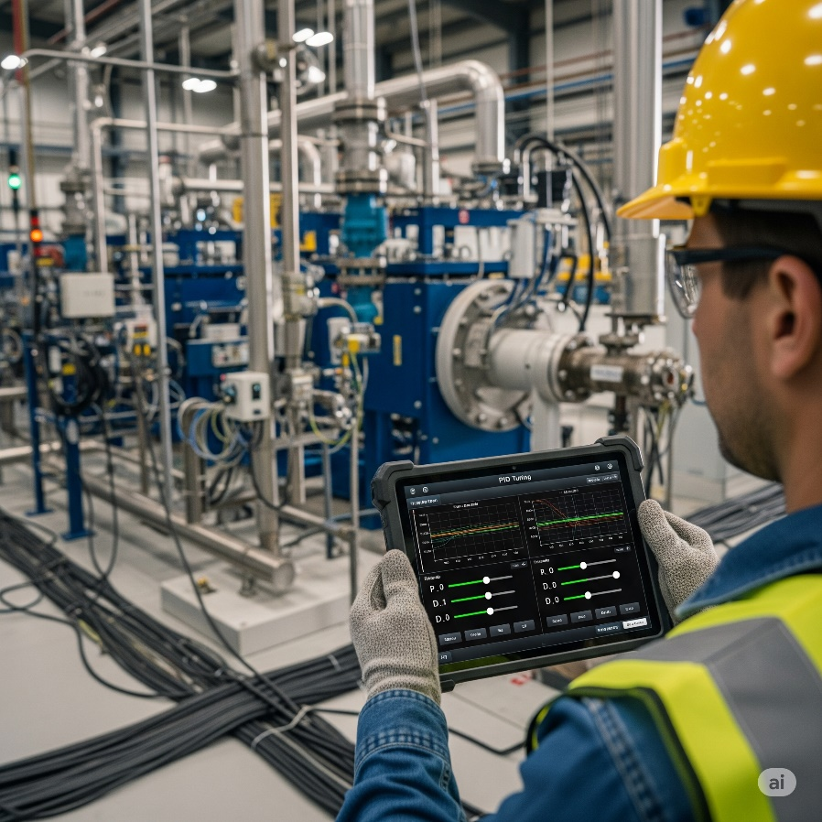

**🧱** 17. Integrated Function Blocks: Programming Shortcuts **🚀**

Function blocks are like ready‑made mini‑programs for common tasks.

**💡** Why it’s clutch:  
Instead of writing dozens of rungs for a PID loop, a motion control routine, or a complex comms setup, you just drop in a block and configure it.  
✅ Faster programming.  
✅ Fewer errors.  
✅ Cleaner, more modular code.

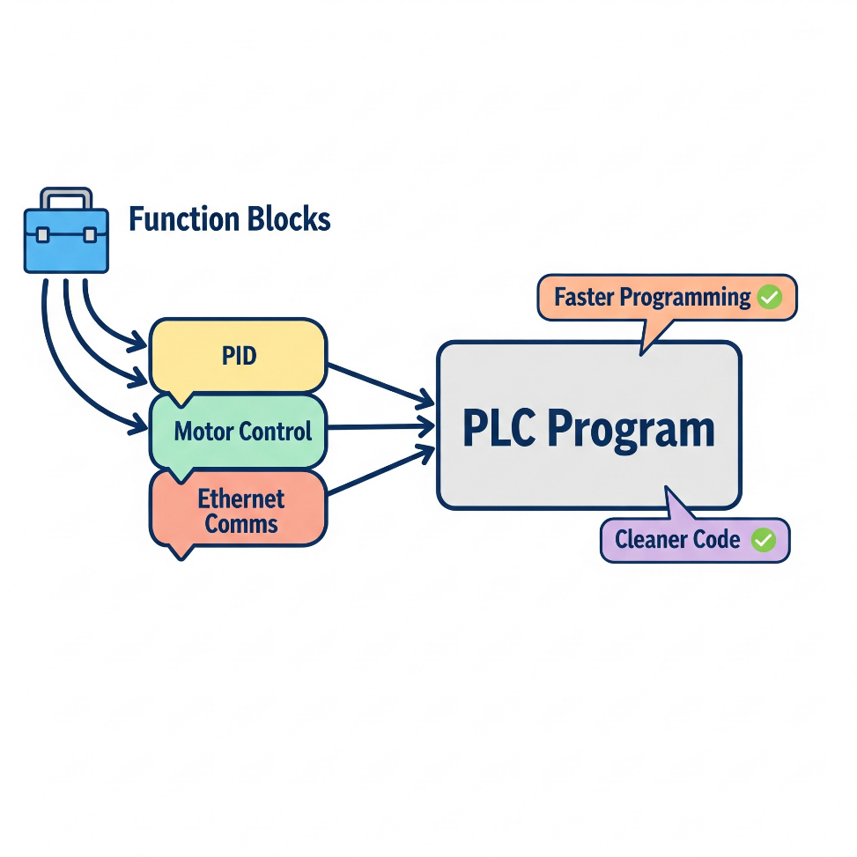

**🗣️** Programming Languages: Speaking Your Language

Ladder Logic still rules the industrial world, but PLCs speak more than one language — so pick what vibes with you:

✅ Structured Text (ST):  
If you’re used to C, Python, or “if–then” logic, you’ll feel at home. It’s text‑based and powerful for math or complex decisions.

✅ Instruction List (IL):  
Hardcore low‑level vibes — if you’ve ever touched Assembly, you’ll get it.

✅ Sequential Function Charts (SFC):  
Organizes your program into clear steps and transitions. Perfect for multi‑stage processes.

✅ Function Block Diagrams (FBD):  
Purely graphical. Drag and drop function blocks to build your logic visually.

💡 Your Move: Ladder Logic is essential, but knowing these alternatives gives you flexibility. Pick the one that makes coding and troubleshooting *feel natural* for you.

**💾** Tag Name vs. Fixed Memory: How Your PLC Stores Data

Different PLCs handle memory differently, and it changes how you work with them:

✅ Fixed Memory Addressing:  
Uses fixed numeric addresses like I:0/0 or N7:0.  
**Pros:** Old‑school reliability, familiar in some legacy systems.  
**Cons:** Less intuitive, harder to maintain in big projects.

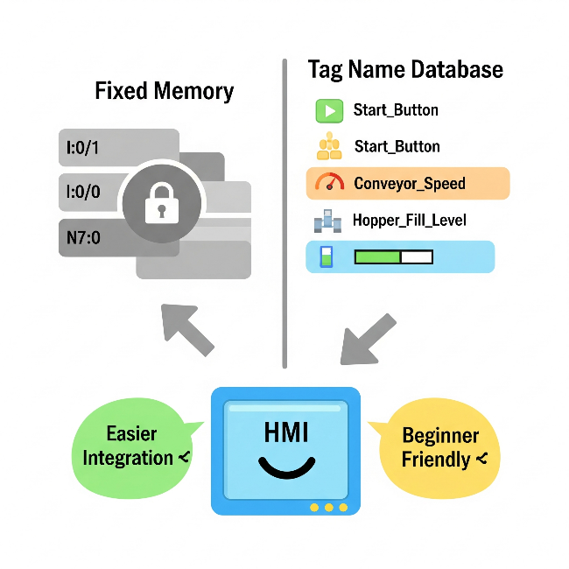

✅ Tag Name Databases:  
Give friendly names like Start_Button or Conveyor_Speed to your I/O and memory.  
**Pros:** Easier to read, way simpler to integrate with HMIs and software, super beginner‑friendly.

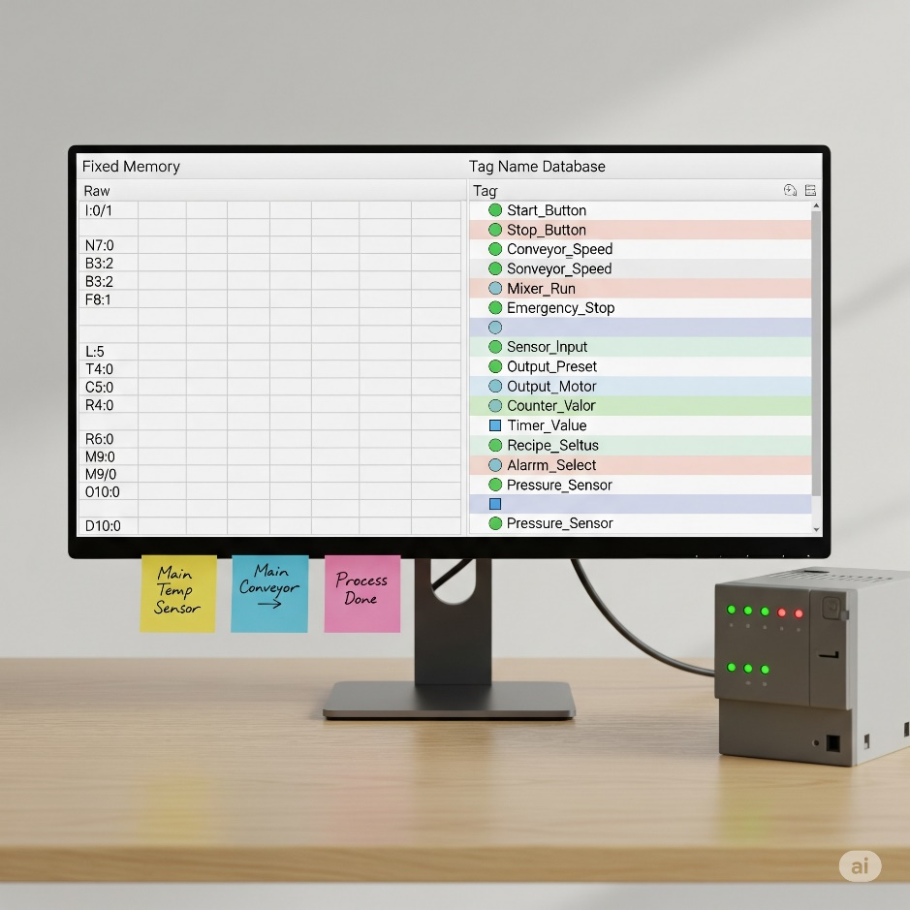

💡 Your Move:

Go with whatever keeps your code clean and makes sense for your project. If you’re working with modern HMIs or big teams, tag names are a lifesaver.

✅ Wrap‑up:  
These extra considerations aren’t the whole universe of PLC features, but they’re the ones that can save your time, sanity, and project deadlines.

Pick tools and approaches that feel natural and fit your workflow — your future self (and your team) will thank you.